

|  |  |  |  |  |  |
| --- | --- | --- | --- | --- | --- |
| **Instructions: For sponsorship, kindly fill in Section A until Section F.**  **For exhibitor, kindly fill in Section A, D, E and F only.** | | | | | |
| 1. **SPONSORSHIP/EXHIBITOR INFORMATION** | | | | | |
| **Company’s Name:** | |  | **Company’s Website:** | |  |
| **Address:** | |  | **Office Number:** | |  |
| **Contact Person & Designation:** | |  | **Mobile Number:** | |  |
| **Email:** | |  |
| 1. **SPONSORSHIP PACKAGES** | | | | | |
| **No.** | **Packages** | | **Select (√ )** | **Sponsorship Package Details** | |
| 1. | Platinum * | |  | Refer to Appendix | |
| 2. | Gold * | |  |
| 3. | Silver * | |  |
| * Automatically entitled a free booth for exhibition | | | |

|  |  |  |  |  |  |  |  |  |
| --- | --- | --- | --- | --- | --- | --- | --- | --- |
| 1. **OTHER FORMS OF SPONSORSHIP: MERCHANDISE/SERVICE/CASH** | | | | | | | | |
| **i. Name & Type of Merchandise/Service Provided:** | | | | **Quantity** | | | **Price Estimation** | |
|  | | | |  | | |  | |
| **ii. Cash Sponsorship:** | | **Amount (RM):** | | | | | | |
|  | |  | | | | | | |
| 1. **EXHIBITOR** | | | | | | | | |
| **Kindly tick (√) the box below:** | | | | | | | | |
| **Select Platinum/Gold/Silver Package.**  **(Entitled free exhibition booth)** | | | **Interested to be an exhibitor.**  **Exhibition Booth Fee:**  **RM 3,000/ USD 1000 RM 1,000/USD 500** | | | **Not interested to be an exhibitor.** | | |
| 1. **PAYMENT ACKNOWLEDGEMENT** | | | | | | | | |
| I enclose a remittance of ***RM/USD***____________________ for sponsorship and/or exhibitor fee** payable to PEDS 2025.  **Cheque No./Bank Draft/Money Order/Wire Transfer or Bank Transfer: | | | | | | | | |
| 1. **OFFICIAL COMPANY’S NAME & STAMP** | | | | | | | | |
|  | | | | | | | | |
| **Payment by Wire Transfer or Bank Transfer to:** | | | | | | | | |
| *Payment in USD*  Name of Account: **IEEE PEDS** Account No: **595-076167-001** SWIFT code: **OCBCSGSG** Bank Code: **7339** Branch Code (if required): **595** Branch Name: **OCBC Centre** Name and address of bank: **Oversea-Chinese Banking Corporation Limited 65 Chulia Street, OCBC Centre, Singapore 049513** *Remarks:* PEDS 2025  *Or Payment in Ringgit Malaysia (RM)*  Name of Account: **IEEE (MALAYSIA SECTION) / POWER ELECTRONICS SOCIETY** Account No:**10-514-001066-4** SWIFT code**:  PHBMMYKL** Branch Name**: AFFIN ISLAMIC BANK BERHAD** Name and address of bank**: Universiti Teknologi Mara, Jln Sarjana 1/2, 40450 Shah Alam, Selangor**  *Remarks:* PEDS 2025  *Email PEDS 2025 Secretariat:* ***aizam@uthm.edu.my or phone: +60123487636*** | | | | | | | | |
| **For PEDS2025 Secretariat’s Use:** | | | | | | | | |
| Received By: |  | | | | Date: | | |  |
| **Terms and Condition** | | | | | | | | |
| 1. PARTICIPATIONS FEE & CANCELLATIONS  1.1 Upon submission of the registration form to the Organiser, the Exhibitor agrees to make full payment within 14 working days from receipt of invoice, or before the event, whichever is earlier. Failing which, the Organiser shall be entitled to cancel the booking made by the Exhibitor. The Organiser shall then have the right to allocate the Exhibitor Booth to another Exhibitor.  1.2 For any cancellation made by the Exhibitor on or before the date of the Exhibition, participation fees will be forfeited. Non-payment or non-attendance does not constitute cancellation.  1.3 For any reason, Organiser decide to cancel or postpone this exhibition, Organiser is not responsible for covering airfare, hotel, or other travel cost incurred by clients.  2. ALLOCATION OF BOOTH AND SET UP  2.1 The allocation of booth(s) is at the absolute discretion of the Organiser, in accordance with the nature of Exhibits or in the manner deemed fit and appropriate.  2.2 Should the Exhibitor decide to engage a contractor other than from the Organiser, the Exhibitor is required to seek approval from the Organiser. The non-official contractor shall undertake to adhere to all Terms & Conditions contained herein.  3. PROHIBITIONS  3.1 The Exhibitors is expressly prohibited from displaying any Exhibits which are unlawful, offensive, explosive or immoral at their Exhibition Booth or hall.  3.2 The Organizer reserves the right to instruct the exhibitor to remove such unlawful or immoral exhibits immediately from the Exhibition Booth failing which the Organiser has the right to remove the same, and the Exhibitor shall be liable to pay the Organiser the costs and expenses incurred.  3.3 The Exhibitor shall not assign, sub-let or allow any other Exhibitor, their agents, manufacturer, employees or supplier to occupy the exhibition space without the consent in writing from the Organiser.  3.4 Exhibitors are not allowed to break down their displays before the close of the exhibition at the time set by the Organiser.  4. RIGHT OF REMOVAL  4.1 The Organiser reserves the right to prevent access or to remove from the Exhibition space (including the Exhibition Booth) any person or persons acting in a way which may cause a breach of peace, or may be considered to be harmful, undesirable or offensive, or may constitute a danger to public safety including the safety of those present at the exhibition.  5. CHANGE OF THE VENUE AND /OR TIME  5.1 The Organiser reserves the right to amend the venue and duration of the event. The Organiser shall accordingly inform the Exhibitor in the Eve of any such change. The change of the venue and duration of the exhibition shall not entitle the Exhibitors to cancel its participation in the exhibition. The Exhibitor hereby agrees that the Organiser shall not be liable for any claim arising from such change.  6. INDEMNITY  The Exhibitor undertakes to fully indemnify the Organiser for any lost items or goods loaned or in the possession of the Exhibitor throughout the exhibition.  7. FORCE MAJEURE  In the event of fire, tempest, explosion of any kind, failure or neglect on the part of any utility supplying electricity or water, labor strife, civil commotion, war, fire or explosions or any other event beyond the control of the Organiser that prevents or hinders the Organiser from fulfilling its obligations under this Agreement, the Organiser shall ensure that the Exhibitor is aware of the occurrence of any such event and to cancel or suspend this Agreement by notice in writing to the Exhibitor.  8. RIGHTS  The Organiser reserves the right at its own absolute discretion to alter the Terms & Conditions contained from time to time without the need to inform the Exhibitor. | | | | | | | | |

SP ONSORSHIP P ACKAGES

|  |  |  |  |
| --- | --- | --- | --- |
| **Sponsorship**  **Packages / Session** | **Platinum** | **Gold** | **Silver** |
| **Company/Individual* Investment Amount** | **RM10,000** | **RM8,000** | **RM6,000** |
| **Company/Individual* Investment Amount** | **USD 2500** | **USD 2000** | **USD 1500** |
| **Benefits** | | | |
| Opportunity to host and industry-related event | Yes | Yes |  |
| Exhibition Booth | Yes | Yes |  |
| Mention in Speech | Yes | Yes | Yes |
| **Complimentary Passes** | | | |
| Exhibitor Pass | 2 | 1 | 1 |
| Exhibitor booth | 2 tables: 3ft x 3ft | 3ft x 3ft |  |
| **Logo Placement** | | | |
| Lanyard | Yes | Yes | Yes |
| Delegate Pack | Yes | Yes | Yes |
| Master Backdrop | Yes | Yes | Yes |
| Lobby Banner | Yes | Yes | Yes |
| Mention in slides/Speech by Chair/MC Before Session | Yes | Yes | Yes |
| Social Media Posting: | Yes | Yes | Yes |
| Advert in E-Program Book: | Half Page (Colour) | Half Page  (Colour)   * ***Only the platinum and gold passes include welcome reception, conference dinner and daily lunch*** * ***Extra table can be charged on site during event. Price may vary***. | Half Page (Colour) |



21-24 July 2025, PENANG

<https://ieee-peds.org/>



SPONSORSHIP BENEFITS



RM10,000

USD 2500

* Exhibition booth
* Mentioned in speech
* The logo on the lanyard, delegate pack, master backdrop, and lobby banner.
* Social media posting
* Advertised in

E-Program Book: Half page (Colour)

* Industry Network
* Logo and link to company URL on the 2025 PEDS website

PLATINUM

GOLD

SILVER

RM6,000

USD 1500

* Social media posting
* Advertised in

E-Program Book: Half page (Colour)

* Logo and link to company URL on the 2025 PEDS website

RM8,000

USD 2000

* Exhibition booth
* The logo will be mentioned in slides or speech before the session by the Chair/MC.
* Social media posting
* Advertised in

E-Program Book: Half page (Colour)

* Industry Network
* Logo and link to company URL on the 2025 PEDS website

**Exhibition Package**

**Exhibition Booth (1m X 1m) (Self own)– MYR3,000/ USD 1000**

* Logo and link to company URL on the 2025 PEDS website
* Logo in email publicity
* No access to conference event/ lunch/dinner
* 2 banner per company

**Stand Banner – MYR1,000/ USD 500**

* Location placement by organizer
* Limited to 1 banners per company
* No access to conference event/ lunch/dinner

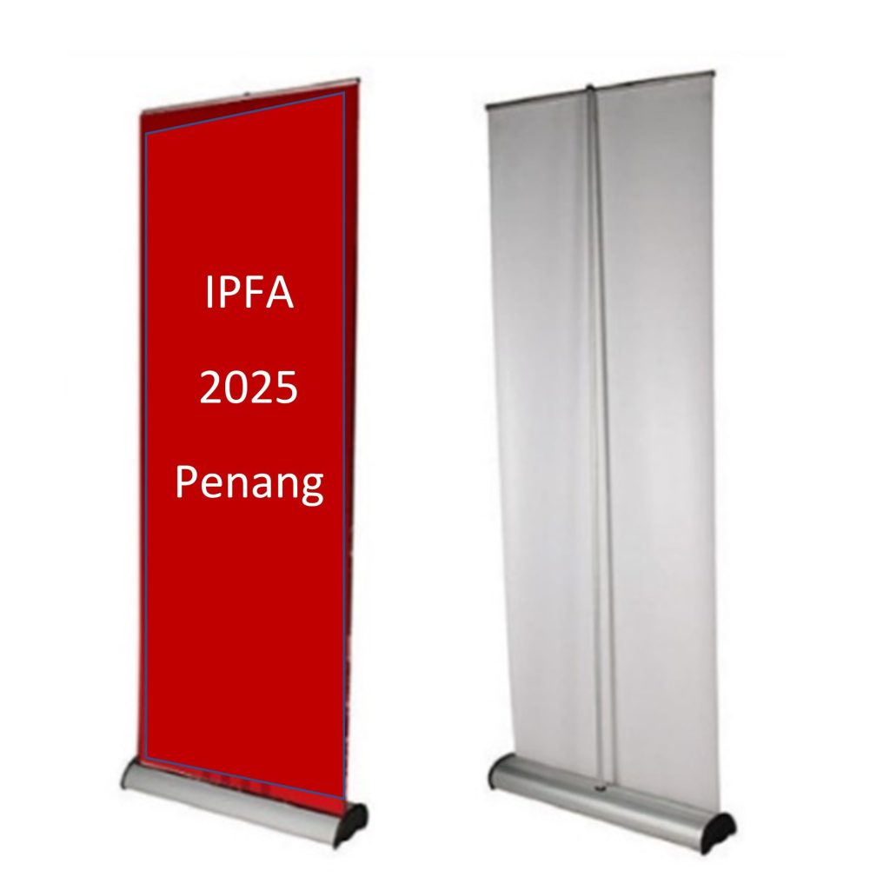



1600mm

600mm

Sample of banner on day of the conference

**HISTORY Of PEDS**

|  |  |
| --- | --- |
|  |  |
|  | |
|  | |

*What is PEDS?*

**IEEE Power Electronics and Drive Systems** (PEDS) conference was founded in 1995 by Prof. Yung C. Liang and Prof. Ramesh Oruganti of IEEE IAS Singapore Chapter. The conference aims to provide a forum for academic and industrial researchers in the area of power electronics and drives for exchange of ideas and for interactions. The conference is a four-day event with technical program consists of one day of short courses/tutorials and three days of technical paper presentations.

*How many participants every conference?*

Estimated **200-300** participants from scientists, academicians and industry experts

*What will be in the Conference?*

There will be **presentation** on latest Power Electronics and Drive technologies from the speaker, **tutorial and workshop** to a specific technology and **industrial networking**.

*Why IEEE PEDS 2025?*

The **15th IEEE International Conference on Power Electronics and Drive Systems (PEDS 2025)** will be held in Penang, Malaysia on 21 – 24 July 2025. The conference is a biennial event and is recognized as one of the major series of conferences in power electronics and drive systems. It will locate at the beautiful beach near Batu Feringi, Penang

*Where the conference paper will be published?*

All the accepted papers and presented papers will be published in **IEEE xplore** database. This database is the most reliable database on Electrical and Electronics research